Remembering Melgre O. Granada
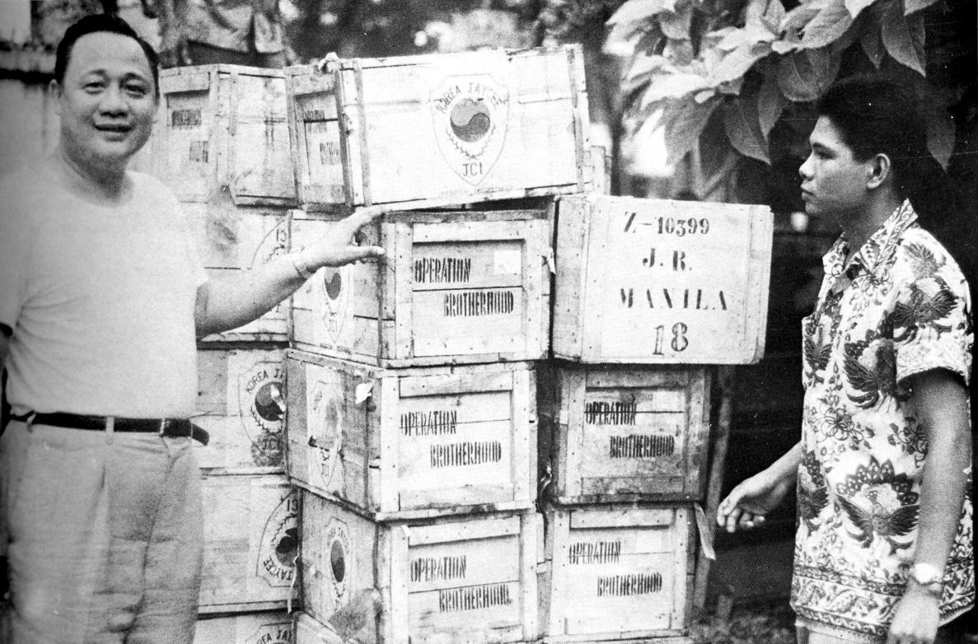
Mel with Oscar

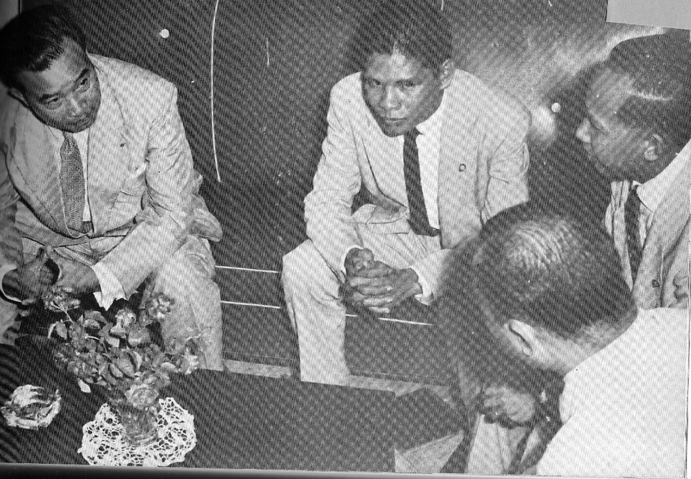
Mel with Souvana
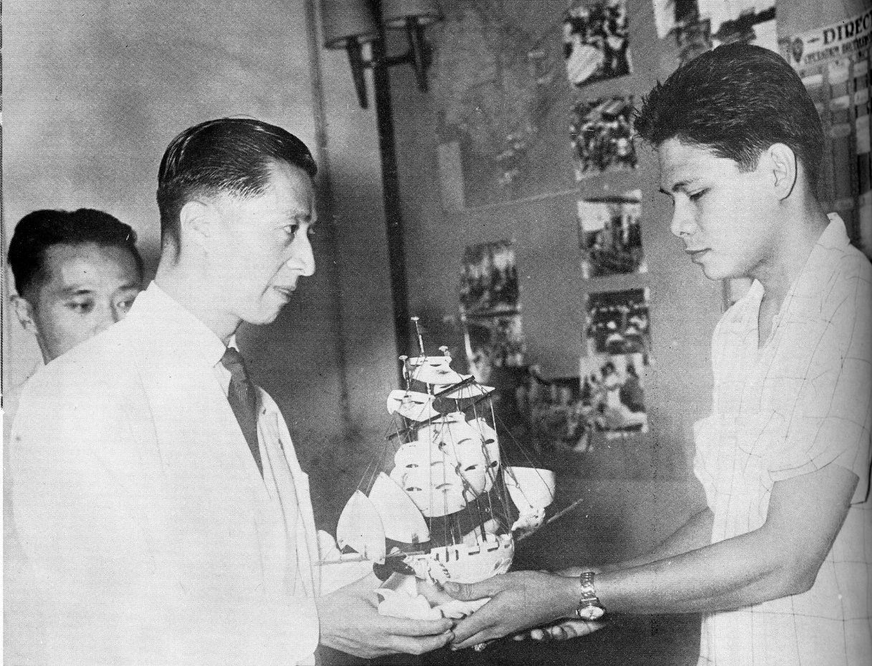
Mel_with Taiwan_Jaycee_head
Operation Brotherhood (OB) Vietnam and OB Laos pioneer was 72. Mel died at the National Kidney and Transplant Center in Manila on October 21, 2013. As the first and only project manager to lead both programs, he achieved a distinction that will remain unique.
Between pages 242 and 243 of Fr. Miguel Bernadʼs monumental 562-page history “Adventure in Viet-Nam: The Story of Operation Brotherhood 1954-1957”, is a multi- page insert of photographs. In all, a collage of 199 black and white prints lays out a two- year panorama when close to a million Vietnamese fled across the 17th parallel that divided North Vietnam from South Vietnam in the wake of the Communist takeover of the North in 1954 by Ho Chi Minhʼs guerrillas. France had lost its Indochinese possessions (Vietnam, Laos and Cambodia) and the world saw the emergence of newly-decolonized countries – South Vietnam among them.
Northern refugees flocked into southern relocation centers by the many thousands. The photos show medical clinics, tents, villages teeming with people bearing that dispossessed look of the lost, the hungry and the sick. Their haven was not exactly the ideal refuge -- its new government was sorely inadequate to cope with the sudden influx. Moreover, it was itself battling the same Communist insurgency within its borders that defeated the French in the north. This was the setting in October 1954 when OB dispatched its first team of medical volunteers from the Philippines.
Shown among the photos are the Filipino organizers of the project, prominent businessmen, legislators, and the prime movers—members of the Philippine Junior Chamber or Jaycees. Thereʼs Oscar Arellano, who as a high ranking officer of the worldwide network of Jaycee chapters, had visited Saigon and saw for himself the woeful plight of the refugees. He rallied the Philippine Jaycees to mount an emergency relief mission. Then he made the rounds of the international Jaycee chapters, finally getting the organization to adopt the relief mission as its world project. In quick time, supplies, personnel, and cash donations poured in.
In one of the photos we see Oscar standing in front of a stack of wooden crates in Saigon, a shipment from South Korea. And there facing him is Mel, looking the youthful 20-year old that he was then. There is another photo of him with former South Vietnamese president Ngo Dinh Diem, with former Philippine President Ramon Magsaysay and with former Laos Prime Minister Souvanna Phouma. What is a teen- aged looking guy doing, rubbing shoulders with these Asian leaders? Oscar had appointed him to manage OB Vietnam in 1954, and when it ended its mission there, to lead OB Laos in 1957. Oscar was the visionary; Mel the executor of those visions.

When, for example, Oscar outlined a program to go beyond curative, emergency health care intervention towards some sustainable, lasting projects to lift the Vietnamese from disease, he envisioned social and economic initiatives. It fell upon Mel to marshal the skills of nutritionists, agriculturists, social workers towards those ends. Vaccination campaigns coordinated with distribution of sewing machines and dispersal of "tilapia" fish fingerlings.
In Vietnam, youth had its embarrassments. Fr. Bernad recounts that “many persons would go to the OB Headquarters in Saigon and ask to see the ʻtop officialʼ or ʻproject managerʼ. Some of these were important visitors from foreign countries. A ludicrous situation would sometimes arise when they found out that the ʻtop official of an internationally –supported operation was a 19-year old boy in a T-shirt!’ Actually he was already in his early twenties.
During the 25 months of OB Vietnam, Mel, as field coordinator, had to contend with a multitude of challenges posed by an extraordinary effort. Volunteers arrived from various countries -- 21 from Taiwan, three from France, four from Japan, three from Hongkong, five from Singapore and Malaya, three from Thailand, two from the USA. The largest contingent were 195 Filipinos. They were physicians, nurses, mechanics, social workers, nutritionists, agriculturists and fishery experts, pharmacists, architects, public health technicians, and administrators. Tons of medical equipment and supplies, food, clothing and other relief goods arrived in Vietnam from various parts of the world. Volunteers lived and worked together, in claustrophobic closeness, spread out across the provinces, some in remote places, struggling against different languages and cultures. Burdensome logistics and irksome government bureaucracy hampered operations . There were casualties – three drowned in Tay-Ninh province: Filipinos Dr. Jose Alejo, nurse Adela Pimentel and Yvonne Ocampo, a Vietnamese-Filipino interpreter. The prospect of such tragedies was ever present because government security against insurgents was not always guaranteed. The country, in essence, was a war zone. Mel noted in one of his letters that “because the Filipino people were poor and could not give as much material or financial aid as other countries, their contribution of personal service was often undervalued. Yet the expenditure of human energy and dedication, sometimes even unto death, can be as great a contribution, even if it is not easily quantifiable.”
When the Lao Jaycees and the Laos Prime Minister invited OB to transfer its operations there in 1956 after Vietnam, Mel, still in his 20s, was again the point man in handling the transition. In some ways, the setting mirrored Vietnam – field teams in remote provinces, volunteers communally living under one roof in spartan conditions, a country in civil war duress. As onsite project manager for three years, Melʼs watch covered some 100 volunteers each year (from 1957 to 1975, about 450 OB Filipinos served in Laos, mostly on two-year contracts). When it left in 1975, forced out by a new Communist government who commanded all foreign aid agencies to leave, OB had also employed some 2,000 Lao.
Tianethone Chantharasy, an officer of the Lao Jaycees said in an email that he was “impressed by his calm, integrity, discipline, dignity and positive attitude. He overcame obstacles and hurdles on many occasions as Laos was then thrown into a period of political turmoil and armed conflicts in areas where many of our OB teams were operating.”
Rod Severino who arrived in Laos in 1959 remembered “He was like a father in Laos, although he was not much older than I. In fact, what I remember most about Mel was his youth. I also aspired to be like him -- someone holding such great responsibilities at such a young age . I remember him playing a mean game of tennis before I even so much as wielded a racquet. I also remember his fluency in French, which was more facile than his Lao -- or Tagalog! (He was Ilonggo.) I aspired to be like him -- in tennis, in French, in administrative skill, at none of which I truly excelled -- unlike him.”
Mel was born in Iloilo City, on July 4, 1931 central Philippines, the third of five children of his parents Roque Granada and Annunsacion Orendain. His father was professor of Languages and History at the Central Philippine University of Iloilo City. He said he grew up in the farmlands of Zamboanga del Norte in Mindanao, southern Philippines.

He studied at the Mapua Institute of Technology. When Arellano was elected as Jaycee Internationalʼs Vice President for Asia, he hired Mel as office manager to organize the Jaycee International Secretariat for Asia that launched OB Vietnam.
After leaving OB Laos in 1961, he worked with Bangkok-based companies Fristan Engineering Company and Time Engineering Company. Back in the Philippines he joined the Presidential Economic Staff of President Ferdinand Marcos, working under Executive Secretary Alejandro Melchor. He was then assigned to the office of Makati (Manila) Mayor Nemesio Yabut as Assistant For Economic Development. Among his projects was the founding of the Makati Medical Center and the Makati Polytechnic College (now the University of Makati). In his later years, he ventured into real estate, wellness centers and rehabilitation clinics.
Commenting on his final Yabut service in 1986, he said " (my) services with the government was terminated at the behest of the people of then President Corazon Aquino who considered those who worked under the administration of President Marcos as tools of the dictatorship."
As a member of Mekong Circle Philippines, he joined its annual reunions hosted by Jovit and Ben Revilla at their Los Banos, Laguna residence. In one photo we see him lined up with our Philippine-based colleagues, now sporting a flourishing, white-haired mane. For our 2008 reunion in Manila, he proposed as part of the festivities a fund raising ball, calling it a “Noche des Ayers” or “La Nuit des Memoires.” He said the organizing committee, employing the political connections of Mekong Circle Philippine president Frisco San Juan with San Miguel Corporation executives, principally SMC chairman Danding Cojuangco, will request the San Miguel Symphony and Choir to play Spanish and French classical music. No doubt he wanted to replicate a March 1955 fund raising event that OB organized at what was then Camp Murphy (now Camp Aguinaldo) in Quezon City. For that event, Mel convinced the Vietnam Jaycees to fly in two planes with 59 members of the Corps de Ballet Royale. There were no ballet dancers at the Manila reunion. But two Filipino sopranos and an elderly singer belting out “ Tatanda Din Kayo!" (You Too Will Get Old) to the mostly aging audience provided the cultural delights.
Mel is survived by his wife Natividad Mercado Granada, 10 children (Matet, Ruffy, Monique, Happy, JP, Gray , Mico, Leohrey, Triz and Melleah) and nine grandchildren.
Messages can be sent to Nati Granada at 70 East Capitol Drive, Barrio Kapitolyo, Pasig, Metro Manila, Philippines. Email: natigranada@yahoo.com or Monique Granada- Morales at niqmorales@gmail.com (#6 Matipid St., Sikatuna Village, Quezon City, Philippines).

